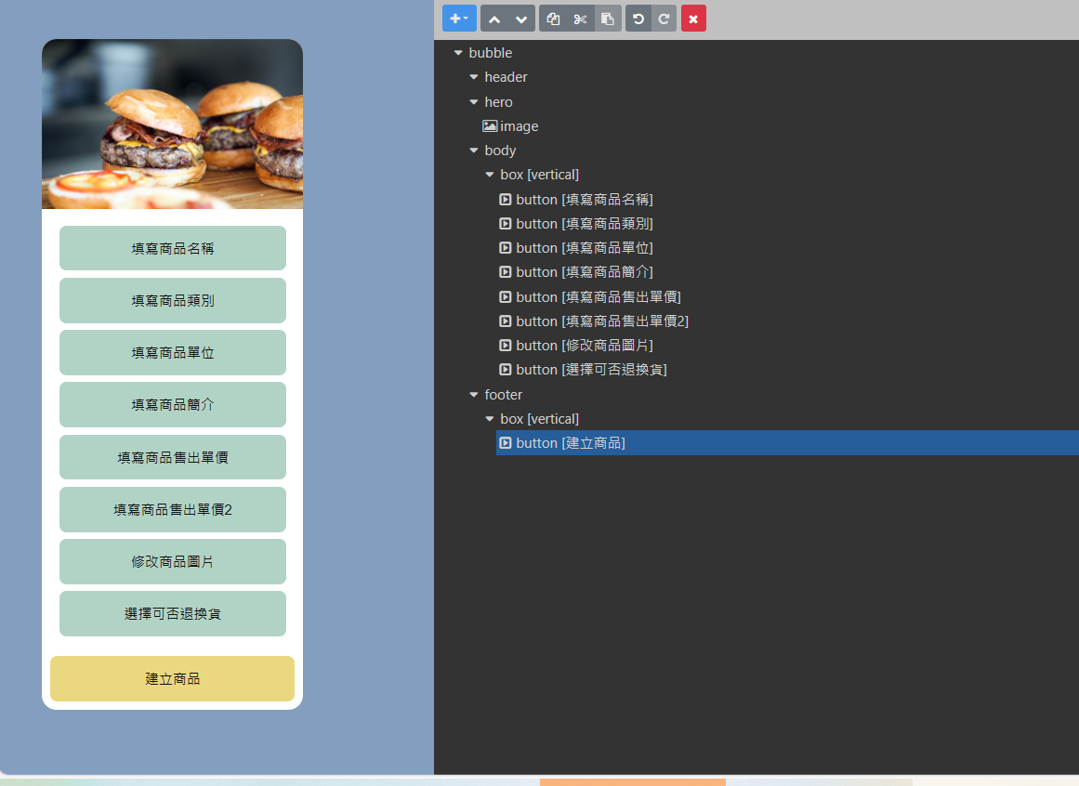

{

"type": "bubble",

"hero": {

"type": "image",

"url": "https://scdn.line-apps.com/n/channel_devcenter/img/fx/01_2_restaurant.png",

"size": "full",

"aspectRatio": "20:13",

"aspectMode": "cover",

"action": {

"type": "uri",

"uri": "https://linecorp.com"

}

},

"body": {

"type": "box",

"layout": "vertical",

"spacing": "md",

"action": {

"type": "uri",

"uri": "https://linecorp.com"

},

"contents": [

{

"type": "button",

"action": {

"type": "message",

"label": "填寫商品名稱",

"text": "填寫商品名稱"

},

"style": "secondary",

"color": "#B1D3C5"

},

{

"type": "button",

"action": {

"type": "message",

"label": "填寫商品類別",

"text": "填寫商品類別"

},

"style": "secondary",

"color": "#B1D3C5"

},

{

"type": "button",

"action": {

"type": "message",

"label": "填寫商品單位",

"text": "填寫商品單位"

},

"style": "secondary",

"color": "#B1D3C5"

},

{

"type": "button",

"action": {

"type": "message",

"label": "填寫商品簡介",

"text": "填寫商品簡介"

},

"style": "secondary",

"color": "#B1D3C5"

},

{

"type": "button",

"action": {

"type": "message",

"label": "填寫商品售出單價",

"text": "填寫商品售出單價"

},

"style": "secondary",

"color": "#B1D3C5"

},

{

"type": "button",

"action": {

"type": "message",

"label": "填寫商品售出單價2",

"text": "填寫商品售出單價2"

},

"style": "secondary",

"color": "#B1D3C5"

},

{

"type": "button",

"action": {

"type": "message",

"label": "修改商品圖片",

"text": "修改商品圖片"

},

"style": "secondary",

"color": "#B1D3C5"

},

{

"type": "button",

"action": {

"type": "message",

"label": "選擇可否退換貨",

"text": "選擇可否退換貨"

},

"style": "secondary",

"color": "#B1D3C5"

}

]

},

"footer": {

"type": "box",

"layout": "vertical",

"contents": [

{

"type": "button",

"style": "secondary",

"color": "#EAD880",

"margin": "xs",

"action": {

"type": "message",

"label": "建立商品",

"text": "建立商品"

},

"height": "md"

}

],

"spacing": "md",

"margin": "md"

}

}